CSCI 271: Assignment 2
Name: Klodian Stafasani Points: _____ / 25
10 multiple-choice questions covering variables, data types, arithmetic, and input/output from Lesson 2. Circle or check the box next to your answer.
1. What does declaring a variable actually do?
☐ B) It reserves a named location in memory with a specific type
2. Which data type should you use to store a single letter grade, like 'A'?
☐ C) char
3. What is the value of int result = 9 / 2;?
☐ B) 4
4. What does cout << 2 + 3 * 4; print?
☐ C) 14
5. What's the difference between << and >>?
☐ B) << sends output, >> reads input
6. What does the escape sequence \t do inside a string?
☐ C) Inserts a horizontal tab
7. Given int x = 5; followed by x = 8;, what happens to the original value 5?
☐ B) x now stores only 8; the 5 is gone
8. What happens when you write int x = 3.5;?
☐ C) It stores 3, silently dropping the .5
9. In the line int total = 5;, which word is an identifier rather than a keyword?
☐ B) total
10. Why is x = x + 1; valid in C++, even though it looks wrong in math class?
☐ B) It updates x by taking its current value, adding 1, and storing the result back in x

Mini Lab: Try It Yourself
// Your task:
// 1. Ask the user to enter their name and age
// 2. Print a greeting using both values

// Example output:
// Hello, I am Choco! I am 1 year old.

Write the C++ program (explain all the lines) and add the screenshot of your output:
#include <iostream>
#include <string>
using namespace std;

int main() {
string name;
int age;

cout << "Enter your name: ";
cin >> name;

cout << "Enter your age: ";
cin >> age;

cout << "Hello, I am " << name << "! I am " << age << " years old." << endl;

return 0;
}
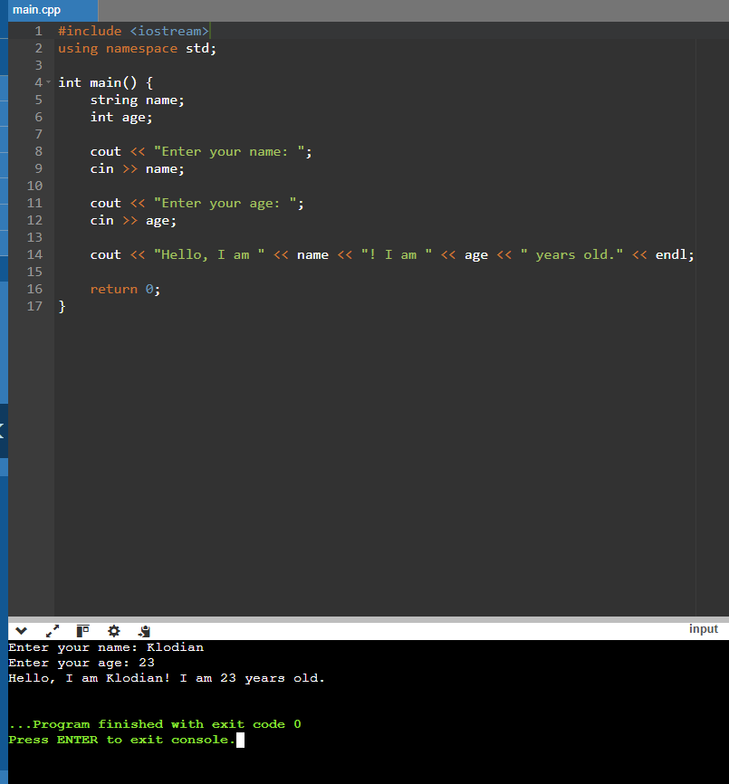

#include <iostream> — This lets the program use cout and cin so we can display things and get input from the user.
using namespace std; — This makes it easier to use things like cout, cin, and string without having to type std:: every time.
int main() { — This is where the program starts.
string name; — This creates a variable called name that will hold the user's name.
int age; — This creates a variable called age that will hold the user's age as a whole number.
cout << "Enter your name: "; — This displays a message asking the user to type their name.
cin >> name; — This takes the name the user types and saves it in the name variable.
cout << "Enter your age: "; — This displays a message asking the user to enter their age.
cin >> age; — This takes the age the user types and saves it in the age variable.
cout << "Hello, I am " << name << "! I am " << age << " years old." << endl; — This prints out a greeting using the name and age that the user entered.
return 0; — This means the program finished running successfully.
} — This closes the main function.

